Day 1 Coding Assessment

Student Management Spring 1

Code:

index.html code:
<!DOCTYPE html>
<html lang="en">
<head>
<meta charset="UTF-8">
<meta name="viewport" content="width=device-width, initial-scale=1.0">
<title>Spring Flowers School - Welcome</title>
<link rel="stylesheet" href="Style.css">
</head>
<body>

<header>
<img src="School Image.jpg" alt="School Logo" class="logo">
<h1>Welcome to Spring Flowers School</h1>
</header>

<nav>
<ul>
<li><a href="index.html">Home</a></li>
<li><a href="profile.html">Student Profile</a></li>

</ul>
</nav>

<main>
<h2>Hello Student!</h2>
<p>Welcome to your online Student Management portal.</p>
<p>Use the menu above to navigate through your profile and other information.</p>
</main>

<footer>
<p>&copy; 2025 Spring Flowers School</p>
</footer>

</body>
</html>

profile.html code:
<!DOCTYPE html>
<html lang="en">
<head>
<meta charset="UTF-8">
<meta name="viewport" content="width=device-width, initial-scale=1.0">
<title>Student Profile</title>
<link rel="stylesheet" href="Style.css">
</head>
<body>

<header>
<img src="School Image.jpg" alt="School Logo" class="logo">
<h1>Spring Flowers School - Student Profile</h1>
</header>

<nav>
<ul>
<li><a href="index.html">Home</a></li>
<li><a href="profile.html">Student Profile</a></li>
</ul>
</nav>

<main>
<section>
<h2>Student Information</h2>
<table border="1" cellpadding="5" cellspacing="0">
<tr>
<th>Field</th>
<th>Details</th>
</tr>
<tr>
<td>Name</td>
<td>Arpit Mahalle</td>
</tr>
<tr>
<td>Class</td>
<td>12th Grade</td>
</tr>
<tr>
<td>Roll Number</td>
<td>33</td>
</tr>
<tr>
<td>Section</td>
<td>A</td>
</tr>
</table>
</section>
</main>

<footer>
<p>&copy; 2025 Spring Flowers School</p>
</footer>

</body>
</html>

Style.css code:

body {
font-family: Arial, sans-serif;
margin: 0;
padding: 0;
background-color: #f4f4f4;
color: #333;
}

header {
background-color: #3c2398;
color: white;
text-align: center;
padding: 15px 0;
}

header .logo {
width: 50px;
vertical-align: middle;
margin-right: 10px;
}

nav {
background-color: #a48d8d;
}

nav ul {
list-style: none;
margin: 0;
padding: 0;
display: flex;
justify-content: center;
}

nav li {
margin: 0 10px;
}

nav a {
color: white;
text-decoration: none;
padding: 10px 5px;
}

nav a:hover {
background-color: #272a1c5f;
}

main {
max-width: 800px;
margin: 20px auto;
padding: 15px;
background-color: white;
}

table {
width: 100%;
border-collapse: collapse;
margin-top: 10px;
}

th, td {
border: 1px solid #9f6969;
padding: 8px;
text-align: left;
}

th {
background-color: #40a143;
color: white;
}

footer {
background-color: #3e9b41;
color: white;
text-align: center;
padding: 10px 0;
margin-top: 20px;
}

input[type="submit"] {
background-color: #569a58;
color: white;
border: none;
padding: 8px 15px;
cursor: pointer;
}

input[type="submit"]:hover {
background-color: #51c657;
}

Reference Image:



Screenshots:

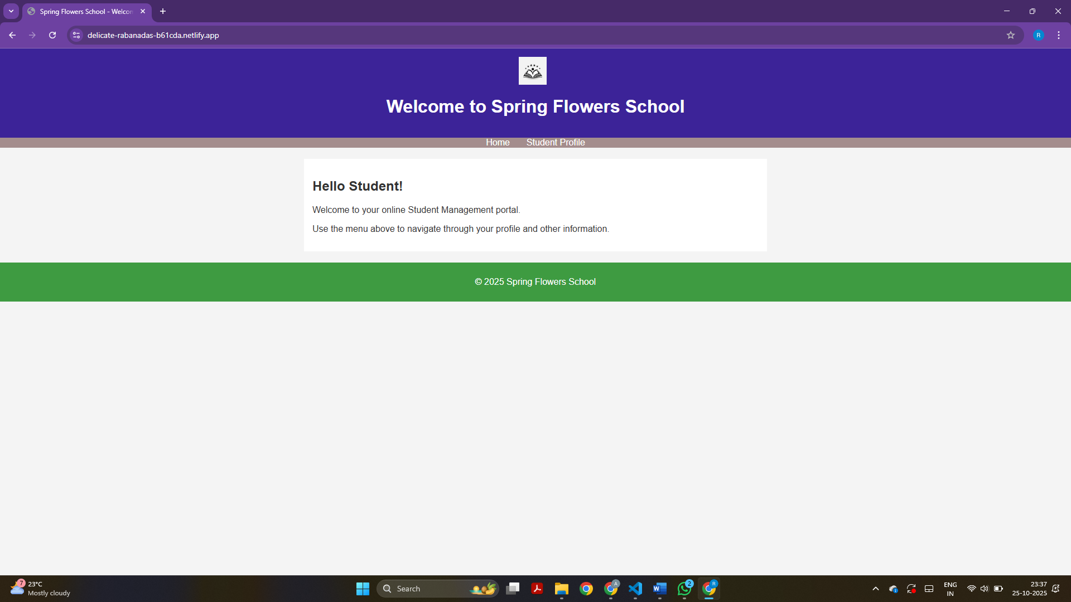

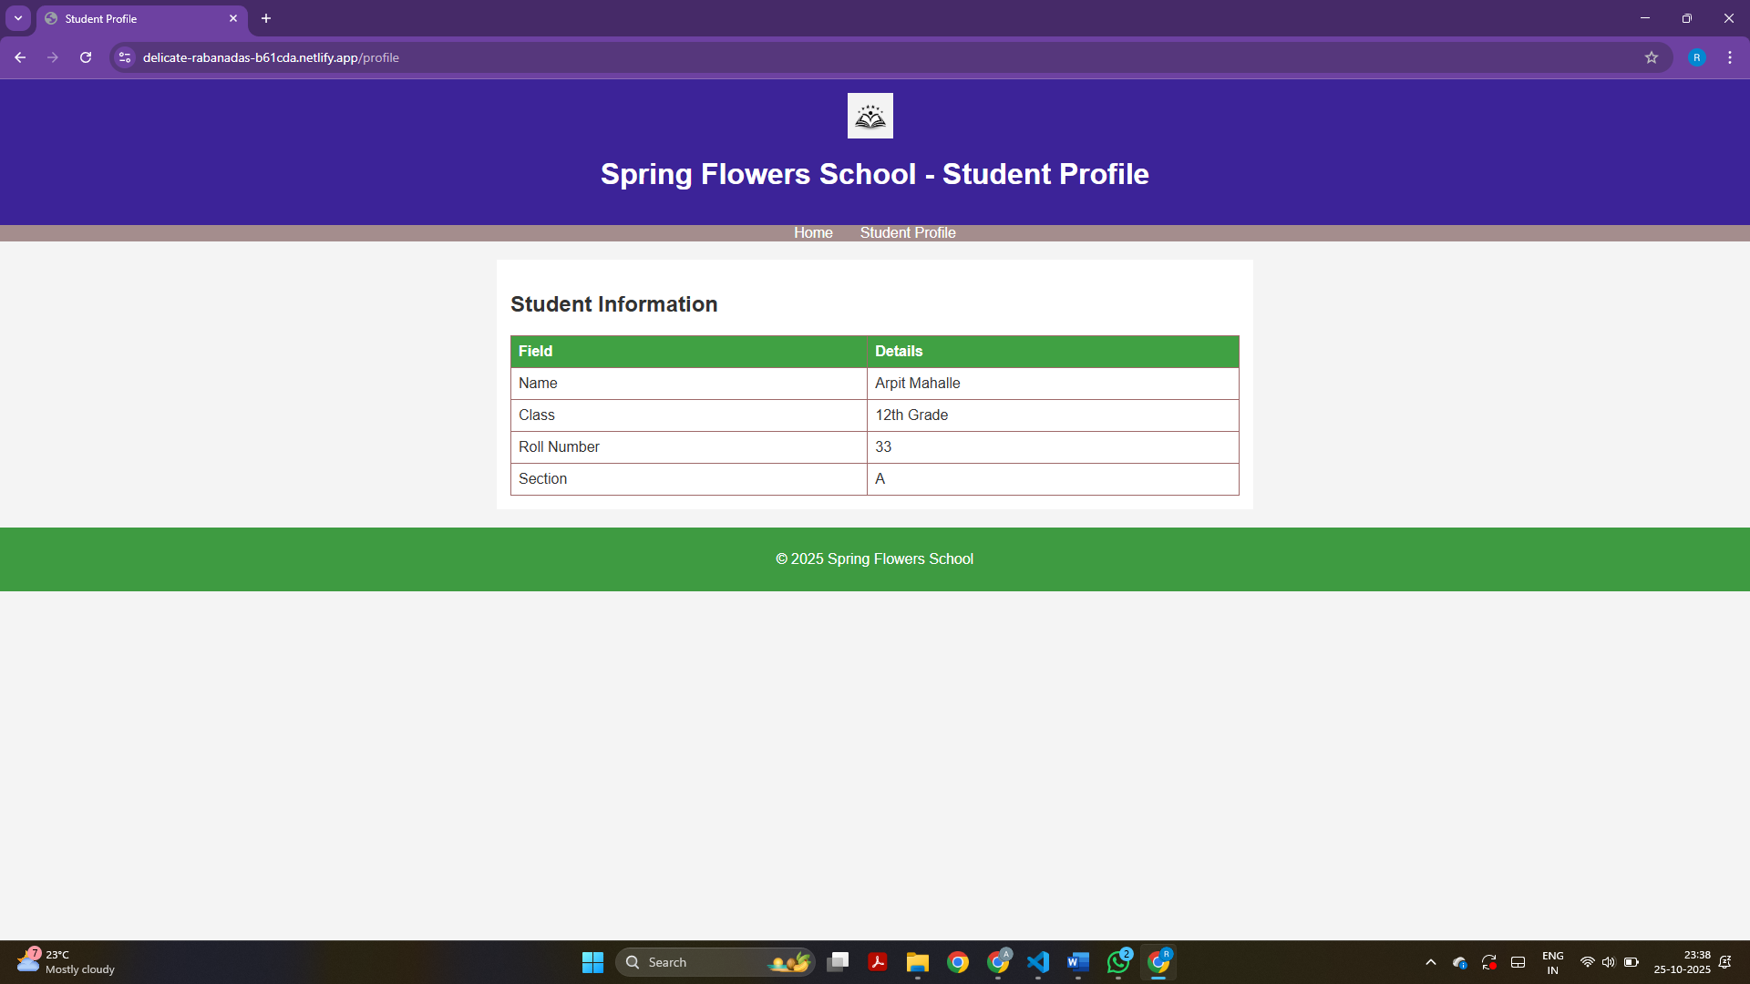

Link: https://delicate-rabanadas-b61cda.netlify.app/

Student Management Spring 2

Code:
index.html code:
<!DOCTYPE html>
<html lang="en">
<head>
<meta charset="UTF-8">
<meta name="viewport" content="width=device-width, initial-scale=1.0">
<title>Spring Flowers School - Welcome</title>

<link href="https://cdn.jsdelivr.net/npm/bootstrap@5.3.2/dist/css/bootstrap.min.css" rel="stylesheet">
<link rel="stylesheet" href="style.css">
</head>
<body>

<header class="bg-primary text-center py-4 text-white">
<img src="School Image.jpg" alt="School Logo" class="logo">
<h1>Welcome to Spring Flowers School</h1>
</header>

<nav class="d-flex justify-content-center gap-3 my-3 flex-wrap">
<a href="index.html" class="btn btn-success">Home</a>
<a href="profile.html" class="btn btn-success">Student Profile</a>
<a href="timetable.html" class="btn btn-success">TimeTable</a>
</nav>

<main class="container text-center my-5 p-4 bg-light rounded shadow">
<h2 class="mb-3 text-success">Hello Arpit!</h2>
<p>Welcome to your online Student Management portal.</p>
<p>Use the buttons above to navigate through your profile and timetable.</p>
</main>

<footer class="bg-success text-white text-center py-2 mt-4">
<p>&copy; 2025 Spring Flowers School</p>
</footer>

<script src="https://cdn.jsdelivr.net/npm/bootstrap@5.3.2/dist/js/bootstrap.bundle.min.js"></script>
</body>
</html>

profile.html code:
<!DOCTYPE html>
<html lang="en">
<head>
<meta charset="UTF-8">
<meta name="viewport" content="width=device-width, initial-scale=1.0">
<title>Student Profile</title>
<link href="https://cdn.jsdelivr.net/npm/bootstrap@5.3.2/dist/css/bootstrap.min.css" rel="stylesheet">
<link rel="stylesheet" href="style.css">
</head>
<body>

<header class="bg-primary text-center py-4 text-white">
<img src="School Image.jpg" alt="School Logo" class="logo">
<h1>Spring Flowers School - Student Profile</h1>
</header>

<nav class="d-flex justify-content-center gap-3 my-3 flex-wrap">
<a href="index.html" class="btn btn-success">Home</a>
<a href="profile.html" class="btn btn-success">Student Profile</a>
<a href="timetable.html" class="btn btn-success">TimeTable</a>
</nav>

<main class="container my-4">
<section class="card shadow p-4">
<h2 class="text-center mb-4 text-success">Student Information</h2>
<div class="table-responsive">
<table class="table table-bordered table-striped text-center">
<thead class="table-success">
<tr>
<th>Field</th>
<th>Details</th>
</tr>
</thead>
<tbody>
<tr><td>Name</td><td>Arpit Mahalle</td></tr>
<tr><td>Class</td><td>12th Grade</td></tr>
<tr><td>Roll Number</td><td>33</td></tr>
<tr><td>Section</td><td>A</td></tr>
</tbody>
</table>
</div>
</section>
</main>

<footer class="bg-success text-white text-center py-2 mt-4">
<p>&copy; 2025 Spring Flowers School</p>
</footer>

<script src="https://cdn.jsdelivr.net/npm/bootstrap@5.3.2/dist/js/bootstrap.bundle.min.js"></script>
</body>
</html>

timetable.html code:
<!DOCTYPE html>
<html lang="en">
<head>
<meta charset="UTF-8">
<meta name="viewport" content="width=device-width, initial-scale=1.0">
<title>Student Time Table</title>
<link href="https://cdn.jsdelivr.net/npm/bootstrap@5.3.2/dist/css/bootstrap.min.css" rel="stylesheet">
<link rel="stylesheet" href="style.css">
</head>
<body>

<header class="bg-primary text-center py-4 text-white">
<img src="School Image.jpg" alt="School Logo" class="logo">
<h1>Spring Flowers School - Time Table</h1>
</header>

<nav class="d-flex justify-content-center gap-3 my-3 flex-wrap">
<a href="index.html" class="btn btn-success">Home</a>
<a href="profile.html" class="btn btn-success">Student Profile</a>
<a href="timetable.html" class="btn btn-success">TimeTable</a>
</nav>

<main class="container my-4">
<section class="card shadow p-4">
<h2 class="text-center mb-4 text-success">Weekly Time Table</h2>
<div class="table-responsive">
<table class="table table-bordered table-striped text-center">
<thead class="table-primary">
<tr>
<th>Day</th>
<th>8:00 - 9:00</th>
<th>9:00 - 10:00</th>
<th>10:00 - 11:00</th>
<th>11:00 - 12:00</th>
<th>1:00 - 2:00</th>
<th>2:00 - 3:00</th>
</tr>
</thead>
<tbody>
<tr><td>Monday</td><td>Maths</td><td>English</td><td>Physics</td><td>Break</td><td>Chemistry</td><td>Information Technology</td></tr>
<tr><td>Tuesday</td><td>Information Technology</td><td>Maths</td><td>English</td><td>Break</td><td>Physics</td><td>Chemistry</td></tr>
<tr><td>Wednesday</td><td>Physics</td><td>Chemistry</td><td>Maths</td><td>Break</td><td>Information Technology</td><td>English</td></tr>
<tr><td>Thursday</td><td>English</td><td>Information Technology</td><td>Maths</td><td>Break</td><td>Physics</td><td>Chemistry</td></tr>
<tr><td>Friday</td><td>Maths</td><td>English</td><td>Chemistry</td><td>Break</td><td>Information Technology</td><td>Physics></tr>
</tbody>
</table>
</div>
</section>
</main>

<footer class="bg-success text-white text-center py-2 mt-4">
<p>&copy; 2025 Spring Flowers School</p>
</footer>

<script src="https://cdn.jsdelivr.net/npm/bootstrap@5.3.2/dist/js/bootstrap.bundle.min.js"></script>
</body>
</html>

style.css code:
.logo {
width: 70px;
height: auto;
border-radius: 50%;
box-shadow: 0 4px 8px rgba(188, 135, 135, 0.3);
transition: transform 0.3s, box-shadow 0.3s;
}

.logo:hover {
transform: scale(1.2);
box-shadow: 0 8px 16px rgba(17, 8, 8, 0.5);
}

header {
background: linear-gradient(135deg, #2b1b65, #4c359c);
color: white;
text-align: center;
padding: 20px 0;
}

header h1 {
text-shadow: 2px 2px 6px rgba(0,0,0,0.5);
}

.button-nav a.btn {
transition: transform 0.2s, box-shadow 0.2s;
}

.button-nav a.btn:hover {
transform: scale(1.1);
box-shadow: 0 4px 10px rgba(0,0,0,0.3);
}

main {
max-width: 900px;
margin: 20px auto;
padding: 20px;
background-color: #fdfdfd;
border-radius: 10px;
box-shadow: 0 4px 12px rgba(0,0,0,0.15);
}

table th {
background-color: #47d04c;
color: rgb(242, 238, 238);
}

table tr:hover {
background-color: #d4f0d4;
}

footer {
background: linear-gradient(135deg, #3cb240, #237926);
color: white;
text-align: center;
padding: 12px 0;
margin-top: 20px;
box-shadow: 0 -2px 6px rgba(12, 0, 0, 0.2);
}

@media (max-width: 600px) {
.logo {
width: 50px;
}
main {
padding: 15px;
}
.button-nav {
flex-direction: column;
gap: 10px;
}
}

Screenshots:

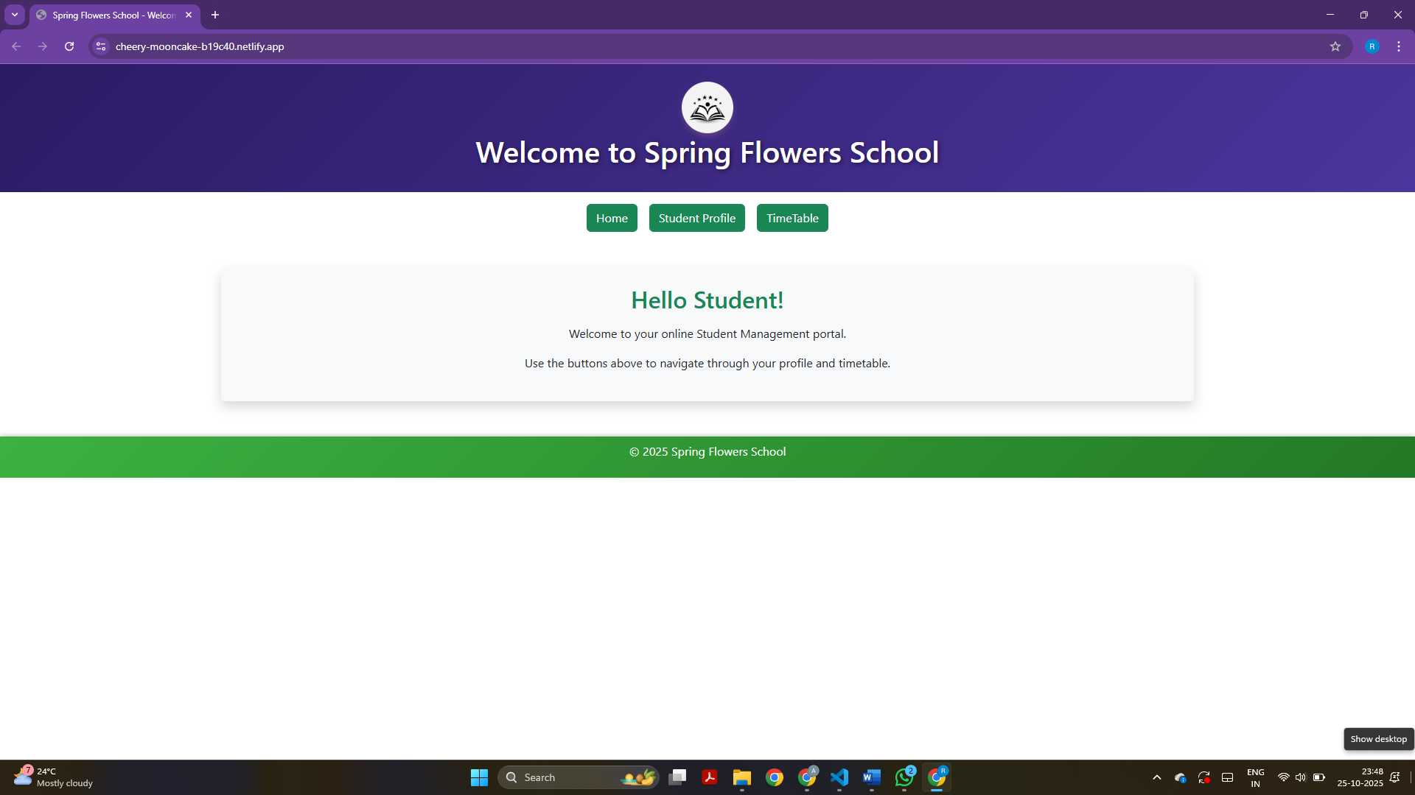
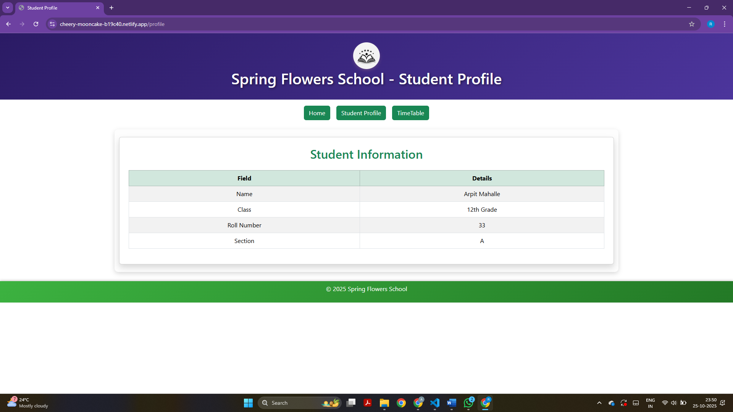

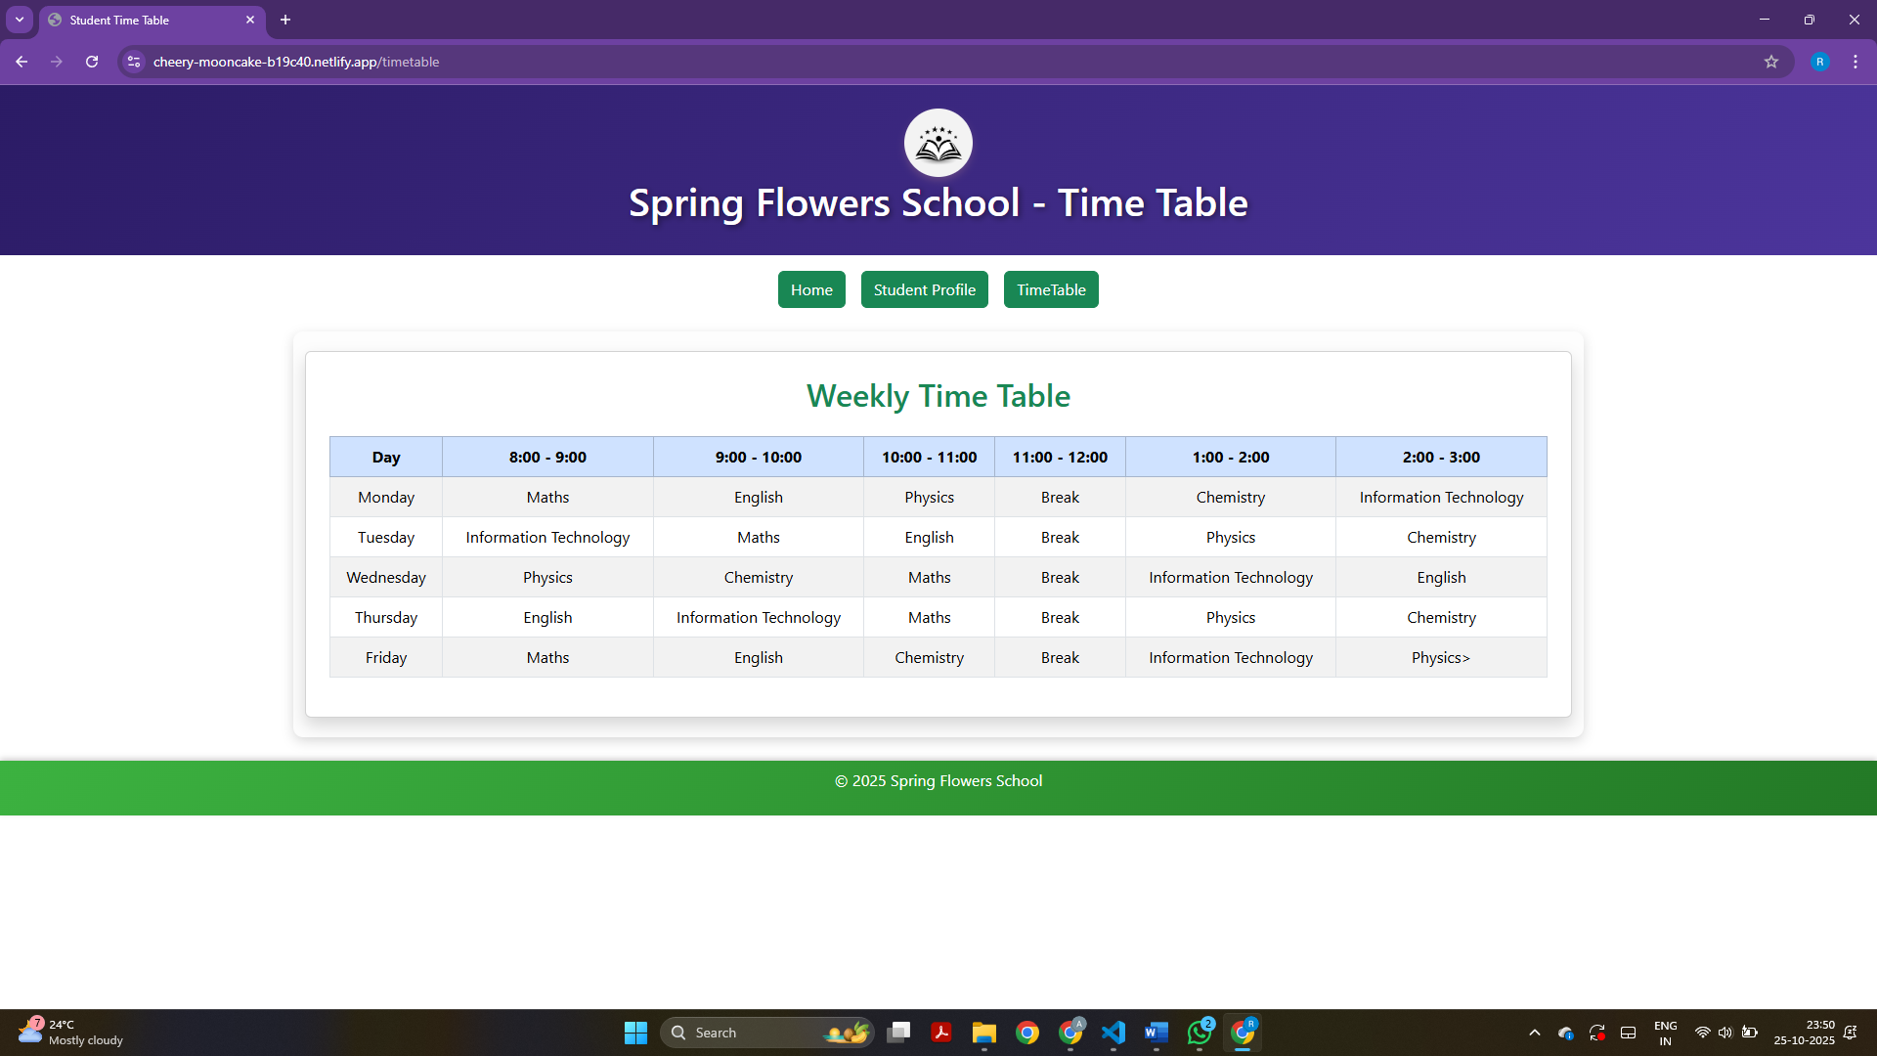

Link: https://cheery-mooncake-b19c40.netlify.app/

